**EUROPEAN UNIVERSITY OF LEFKE**

FACULTY OF ENGINEERING

Graduation Project 2

School Bus Tracking and Information Website

### Andile Nleya

### 164611

**Supervisor:**

Prof. Zafer Erenel

June 2021

**ABSTRACT**

The project is about a formal website for the school bus. It is more of an informative and does not have much interaction. The users are defined in two groups Admin and user. User includes the students and the drivers. User will only be able to view the website after a successful login. It will have a login module, news module, employee’s module, about us module, and routes module for user. Students and drivers will also be able to monitor the movement of the bus using the esp32 and gps module installed in the bus. They will also get the latest updates on the bus. The admin, on successful login will be redirected to admin panel where they can add announcements, change the bus timetable and also the working hours for the drivers. The admin can also edit the user information database and add new users. There will be a portal for interaction between the users and the admin. Users will enter their quiry and it will be send via mail to the admin. The system will be developed using HTML, CSS, and JavaScript for the front end, PHP and PHP mailer for backhand, MySQL to manipulate the Database, an ESP32 with GPS-neo6m module for tracking and Thingspeak online database to act as a link between my hardware and my software. This website will help the students to catch the bus on time at different bus stops. The admin will be able to ensure the safety of the student by following the bus movements. This site will make it easier to access information and any updates on the buses. The documentation will explain each and every process of the project in detail and how all of the processes connect to each other to make a complete system.

**Table Of Contents**

Your Name Surname i

Your Student Number i

Your Supervisor Name i

Publish Date i

1.Introduction 1

1.1 Problem definition 1

1.2 Goals 1

2. Literature Survey 2

3. Background Information 3

3.1 Required & Used software 3

3.2 Other software 3

3.3 Hardware 3

4. Design Documents 4

4.1 Context diagram 4

4.2 Data flow diagram 4

4.3 Use case diagram 4

4.4 ER diagram 4

4.5 Hardware connection 4

5. Methodology 5

6. Conclusion 6

6.1 Benefits 6

a. Benefits to users : 6

b. Benefits to me : 6

6.2 Ethics 7

6.3 Future Works 8

7. References 9

# 

# 1.Introduction

## Problem definition

Nowadays, almost all schools have websites that have all the information one can need. For example, the European University of Lefke (EUL) has a school website [1] with a page that has some information about the school bus. The page is not easy to find because there is a lot of other pages in the school’s only website and information provided is very minimal and not updated regularly. I will create a separate website that focuses only on the school bus. It will have less traffic compared to the school website and it will be more user friendly.

My website will accommodate the employees (bus drivers) as they will also be allowed to access information after login. This way they will also be able to check their working timetables digitally and be easily notified if there are any changes or updates. The administrator will be able to post general information about the buses, a detailed timetable for the bus movements that can be used even by a new student, a shifts timetable for the drivers, a regular newsletter for announcements. Admin will also be responsible for managing all the users. They can edit or delete user from the database and add a new record for a new user.

I will introduce live GPS tracking for all the routes taken by the different school buses at a particular time. Our school buses already have working wifi making it easier to install the tracking system that can be accessed on the website. As a student, I know the struggle of waiting for the bus for too long or being late because the times are not the same for each trip due to different factors like traffic. The GPS will eliminate that problem since the student will be able to monitor the bus movement. This will generally increase the effecience of the school transportation. The school bus website has been implemented by Colombia University for their shuttle services [2]. This example will be discussed later.

## Goals

* To create an easily accessible school bus website that provides relevant information.
* To provide a platform for posting regular newsletters for new announcements about the buses
* To provide easy communication between users and admin for issues strictly concerning the school buses
* To include a tracking system for the school bus movement to improve student's life
* To include a module for bus drivers to access their shift timetables and any important announcements that may affect the.

# 2. Literature Survey

Most institutions have not implemented a separate website for their bus services. I did come across some that have been able to implement a separate website and also provide some features that I want to include in my project. I will be discussing three different examples including EUL.

**Example 1**

**EUL** has a page under their official school website for transportation. It is just a single page with a drawn map of the places around the school and pictures the timetables for movement which are not easy to understand. The page is not informative and updates about the school bus are not shown. My website will provide all the necessary news. The timetables for the different routes are in separate pages. I also will include a gps tracker for the busses and a page for the employees which is not available on the EUL web page.

*EUL Transportation webpage*

Figure 1

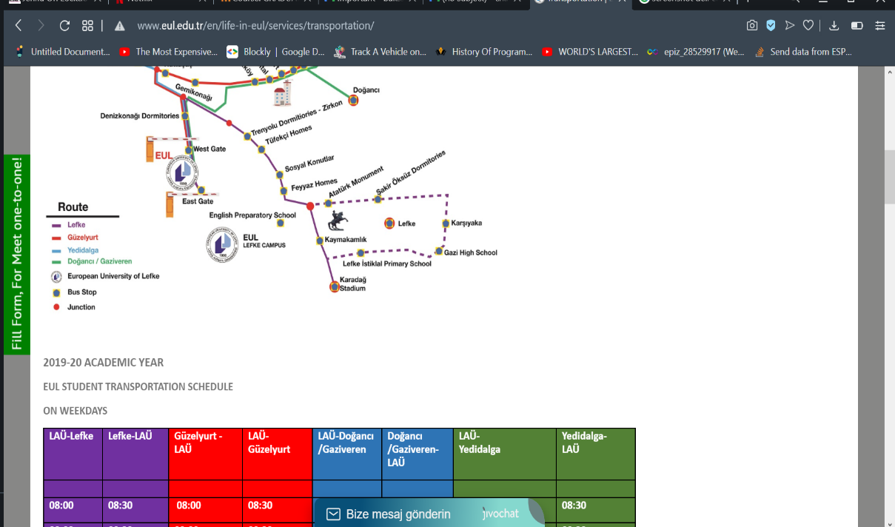

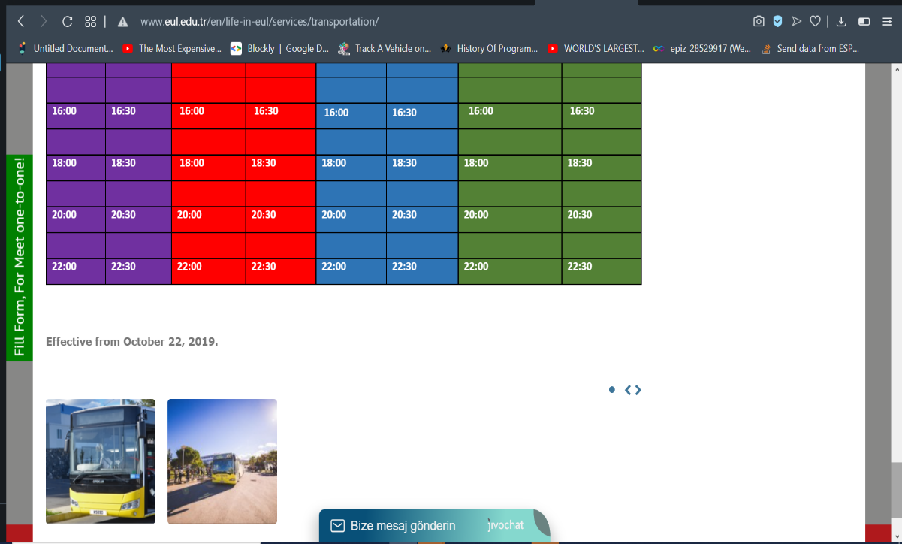

*Figure 1.1*

**Example 2**

**Harvard University** has a more detailed transportation web page. It has a list of guidelines and requirements for passengers and drivers that are kept up to date. They have a link list of their services which go to separate pages. On the top right of the page, there is an option to track the shuttle movements from google maps. There is a list of shuttles that are in service and an option to search for a particular route to track. They also have a service alert page for important announcements. These features are some of the similarities with my own system.

The major difference will be that mine will be a separate website from the school's official website. Users will also have to be logged in to access information for my website which is not the case for Harvard university. They also did not include any information about their employees. My users (including students and drivers) will be able to view the drivers daily schedule on the employee module. The different routes taken do not have separate pages unlike on my site.

Figure 2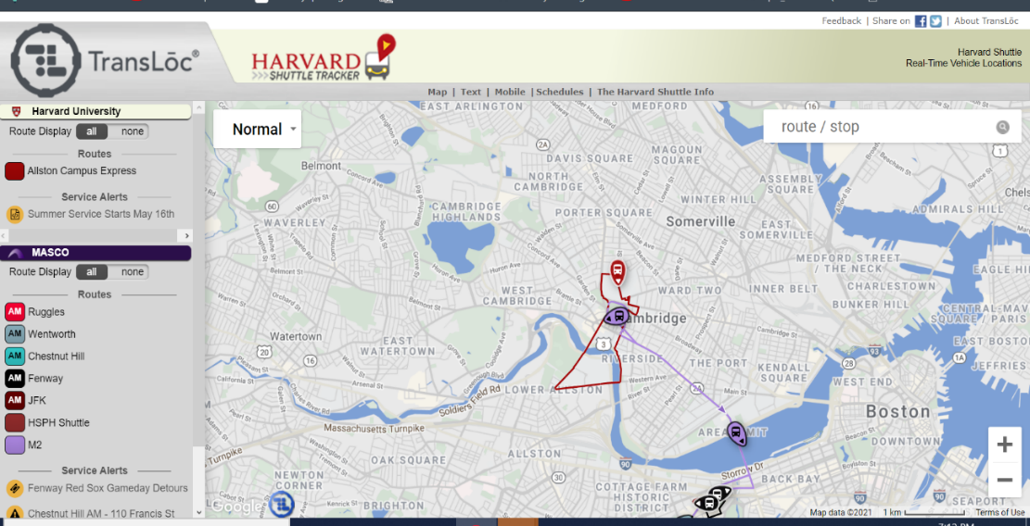

*Harvard University Transportation*

**Example 3**

**Columbia University** created a Columbia Transportation website. My project will mainly be based on this example. The website has a simple and user-friendly user face. Their menu shows travel options, car rental options, parking and parking policies for car owners, about us, and contact info. My website will be strictly about the school bus and its movements. Colombia University, just like Harvard, did not include any information concerning the drivers. Their pages have a couple of images but I will include a separate gallery on the about us page to add images concerning the school transportation department. . Another difference between my site and theirs will be the login module. Only students and employees will have access

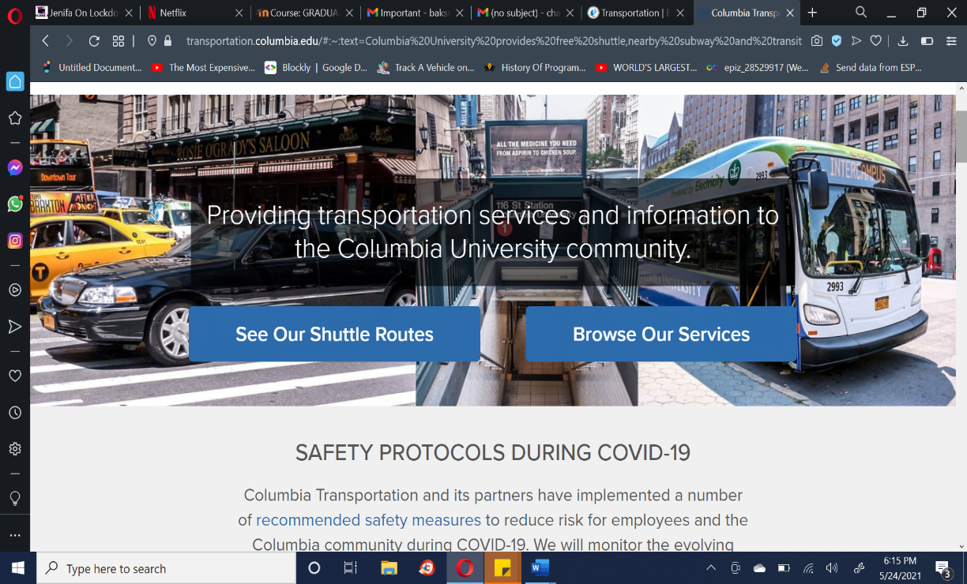

*Figure 3. Columbia University Shuttle: Home page*

The main page has safety protocols, news, and announcements section written in detail. This is a feature that I will be including as it is goal to help students stay informed and safe. There are buttons to go to a different page for Shuttle Routes, Browse Services, and checking for more updates. Colombia's shuttle tracker is also functional on the website but it can be accessed on an application that they partnered with. It is one google map that displays different routes at request. I will also include the tracker on the website but mine will redirect to a different page for each route. Overall, the Colombia Transportation website has a very conducive layout that I will use for reference throughout my project.

# 3. Background Information

## 3.1 Required software

* **HTML:**

Hypertext Mark-up Language is the most basic tool for building a website. It is used to define the elements of a webpage and the layout. This includes elements like lists, tables, images, paragraphs, links etc. It is a standard language and very easy to understand. HTML is usually used together with Cascading style shit and JavaScript for the front end of the website. I used HTML to structure all the pages in my website.

* **CSS:**

Cascading Style Sheets is used to enhance the presentation of a webpage written with a markup language ( HTML or XML). This includes styling the font, describing the layout, and including colors. It is independent. It is saved in a css file but styling can also be done inline with the markup language. CSS designs add uniqueness to a web page. It also allows the web pages to adapt to different devices that a user can have such as phone, laptop and printers.

* **JAVASCRIPT:**

JavaScript, usually written JS, is an interpreted and high-level programming language that has first-class functions. It conforms to ECMAScript specification. JavaScript has many uses but it is mainly used in the front end of web design. It is text based and can be used for both server and client side. Html and CSS design and style the outlines of a website while Javascript makes the elements interactive I used Javascript for my dropdown menu and for alerts. On the server side, I used JS to get coordinate values online and display the google map for tracking and other functionalities.

* **Bootstrap:**

Bootstrap provides an open and free framework for developing a website using CSS, HTML and Javascipt. It includes already made functions to simplify web development. I used bootstrap for my menu, my fonts and other elements of my pages. It also provides optional Javascript templates for different components of the website. Bootstrap provides responsiveness to a webpage on the mobile. Bootstrap file are available for download on the bootstrap website and the link has to be included in the HTML header tag.

* **XAMPP**

**Xampp** which abbreviates Cross-platform, Apache, MySQL, PHP and Perl is a web server developed by Apache Friends. It is a free and open-source package that allows users to build website offline and host them on the local web server of the computer. Xampp offers a php admin where a user can build database and manipulate them using MySql. All the documents needed for the project are stored in the xampp file and user only has to type localhost/nameofwebpage on any browser on they computer to access the website.

* **PHP:**

PHP (PHP: Hypertext Pre-processor) is a scripting language on the server side that can be embedded in HTML and is widely used in web development. It is used on the back end to create databases and in the management of dynamic content. In my website, PHP is used for communication with the database using MySql. It is necessary for functions like connecting to the database, verifying if user exists in my login page , displaying database info for user, admin dashboard for operations like creating a new user in the database. Php scripts work on a server that already installed PHP. It is free, fast and very easy to use.

* **PHPMailer:**

PHPMailer is an already made library code that is used to transport emails easily and safely. It is used with an HTML form, SMTP protocol and is autenthicated using transport layer security (tls). PhpMailer can send plain text or Html type messages depending on the type of client. It has a debugging system that keeps all operations secure. PhpMailer can identify many different errors and explain them to the user incase an email fails to send. All the nesessary codes are downloaded from github and placed in my htdocs.

* **MySQL:**

MySQL is a database management system that uses structured Query Language. MySQL organizes and processes data that is stored in a database. It works hand in hand with PHP for real time interaction with my website. SQL language is used in MySql to perform queries like edit, create, extracting data and managing user access from the database. MySQL is free and has an open-source nature that provides advanced features with built in functions for simple coding and is very reliable. It comes already installed in the Xampp application.

* **Arduino IDE**:

This is an integrated development environment that is used to upload a code into a hardware device. It is written using C/C++. Arduino IDE provides libraries for different functions and can also be used for communication between two components. In this project I used it to program and enable communication between my ESP32 and GPS module.

* **Thingspeak:**

This is an IoT application that uses an API to receive data, store it and also send data out. Arduino ide provides a Thingspeak library that enables me to use a wifi connection to send my gps coordinates which will be retrieved by my website so as to be able to display my location.

## 3.2 Required Hardware

* **ESP32 Dev Board:**

ESP32 is an open-source electronic device made of both hardware (microcontroller) and some software on the computer to write and upload code to the hardware. It can operate as a slave and connect to another microcontroller unit or as a standalone and be programmed on its own. It has a USB port for powering. ESP32 has intergrated Bluetooth, WiFi and provides a connection. I will connect it to the GPS module using SoftwareSerial communication to get the gps coordinates and use the WiFi connection to send them to Thingspeak.

* **GPS – NEO6M module**:

This is a global positioning system. It has an antenna to communicate with the nearest satellite. The satellite provide the latitude and longitude of the module. TinyGPS++ library is used in the Arduino IDE to extract the information and perform certain function.

# Design Documents

## Context diagram

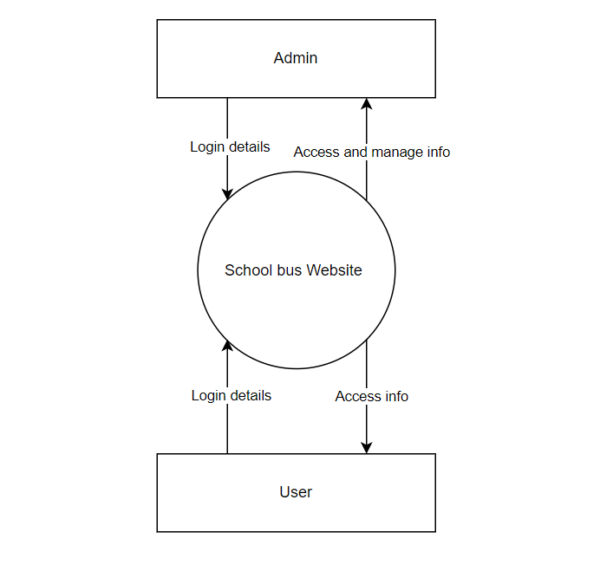

*Figure4. Context Diagram*

The context diagram above shows the simple data relationship between the system and the entities which are (user and admin) represented by rectangles. It is also called level one data flow diagram. This is because it only has one process which is the system represented by the circle. Both user and admin send their login details and if they are verified they can access information from the system.

## Data flow Diagram

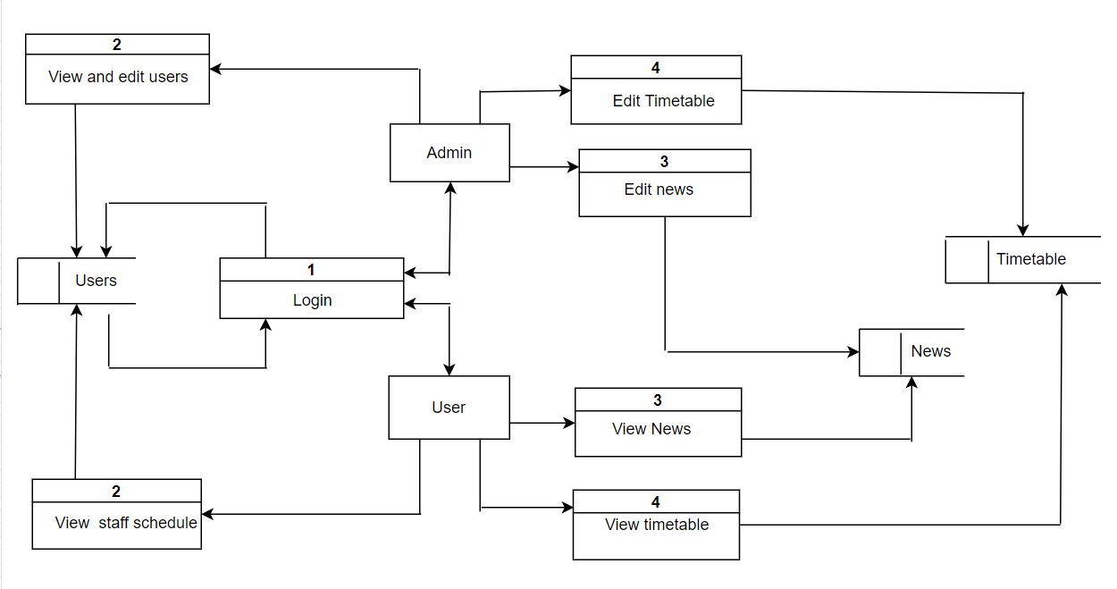

*Figure6 Data flow diagram*

Data flow diagram represent all the processes in the system and their relationship with entities and data storage. The diagram above is a level 2 dfd. It has

* 4 processes numbered 1-4 represented by rectangle with a horizontal line

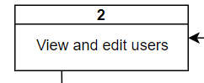

* only 2 entities (Admin and user) represented by a regular rectangle

* Three data storage tables represented by arectangle with no border on the right side

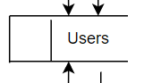

* The arrows represent the direction of flow of data or command.

In process 1, Admin and Users log in their details and the system checks for the data in the user table and if its available login is success. Admin peforms other processes edit news, edit timetable and edit users. Users perform other processes like view news, view staff schedule and view timetable. All processes are connected to a table in the database.

## Use case diagram

Use case diagram below shows a graphical description of all the possible operations a user can perform on a system. The users can either be Admin or user.

* User is represented by the stick human

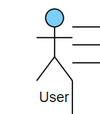

* The operations performed by each user is represent by an oval shape

On the diagram, the login process is link to the other processes with an (<<include>>) this tells that the user cannot access the other pages if they have not successfully completed the login .

**Admin can:**

Login, Edit user, Edit news, Edit timetable, logout.

**User can:**

Login, View news, View timetable, logout.

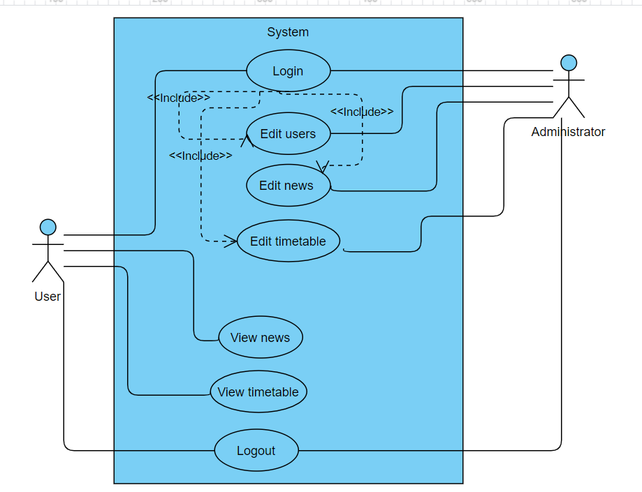

*Figure7 Use case diagram*

**Use case scenarios**

**Scenario I: Admin login scenario**

**Actor: User (Admin)**

**Normal Flow:**

1.User logs into the system

System authenticates login info and directs them to admin panel.

**Alternative Flow:**

1.System displays error message if login not successful .

**Scenario 2: Update users scenario**

**Actor: User (Admin)**

**Normal Flow:**

1.User logs into the system

System authenticates login info and directs them to admin panel.

2. User views users information and clicks on edit.

System displays a form to edit user information.

3. User edits information .

4. User clicks on the ‘edit’ button.

System edit the users information and goes back to users info display.

**Alternative Flow:**

1.System displays error message if login not successful .

2.System refuses to add information; if wrong or no information is entered system displays error

**Scenario 3: Add new user scenario**

**Actor: User (Admin)**

**Normal Flow:**

1.User logs into the system

System authenticates login info and directs them to admin panel.

2. User views users information and click on create new user.

System displays a form to add user information.

3. User adds users information .

4. User clicks on the ‘add’ button.

System add the new record to users information and goes back to users info display.

**Alternative Flow:**

1. System displays error message if login not successful .
2. System refuses to add information; if wrong or no information is entered system displays error

**Scenario 4: Delete user scenario**

**Actor: User (Admin)**

**Normal Flow:**

1.User logs into the system

System authenticates login info and directs them to admin panel.

2. User views users information and clicks on delete.

System displays a form to edit user information.

3. User clicks on the ‘delete’ button.

System deletes the user and goes back to users info display.

**Alternative Flow:**

1. System displays error message if login not successful .

**Scenario 5: Add news scenario**

**Actor: User (Admin)**

**Normal Flow:**

1.User logs into the system

System authenticates login info and directs them to admin panel.

2. User views current news and clicks on change announcement.

System displays a form to add news.

3. User adds information .

4. User clicks on the ‘and’ button.

System edits the news section and goes back to dashboard.

**Alternative Flow:**

1. System displays error message if login not successful .
2. System refuses to add information; if wrong or no information is entered system displays error

**Scenario 6: Update timetable scenario**

**Actor: User (Admin)**

**Normal Flow:**

1.User logs into the system

System authenticates login info and directs them to admin panel.

2. User views current timtable and clicks on change.

System displays a form to edit timetable.

3. User edits information .

4. User clicks on the ‘edit’ button.

System edit the timetable and goes back to dashboard.

**Alternative Flow:**

1. System displays error message if login not successful .
2. System refuses to add information; if wrong or no information is entered system displays error

**Scenario 7: User login scenario**

**Actor: User (user)**

**Normal Flow:**

1.User logs into the system

System authenticates login info and directs them to home page.

2. User clicks on news .

System displays current news updates.

3.User clicks on routes .

System dislays routes timetable

4. User clicks on our employees button.

System displays drivers work schedule.

**Alternative Flow:**

1. System displays error message if login not successful .

## 4.4 ER Diagram

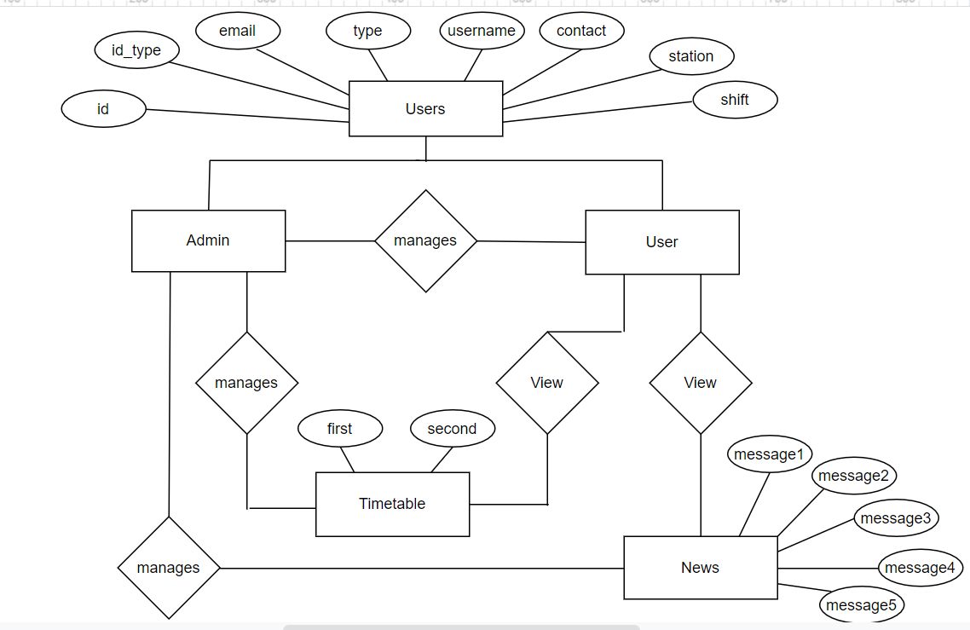

*Figure26 er diagram*

## ER diagrams represents the interrelationship between particular entities in a system. It describes in detail, the attributes in each entity and how it is connected to the other entities.

The layout:

1.The entities are represented by a rectangle

And these are Users(Admin and User), News and timetable.

2.The attributes of each entity are represented by an oval shape

For example, out timetable has attributes first and second.

3.The relationship between each entity is represented by a diamond.

Example the Admin manages User.

## 4.5 Hardware

**Material used:**

1.Esp 32 dev board x 1

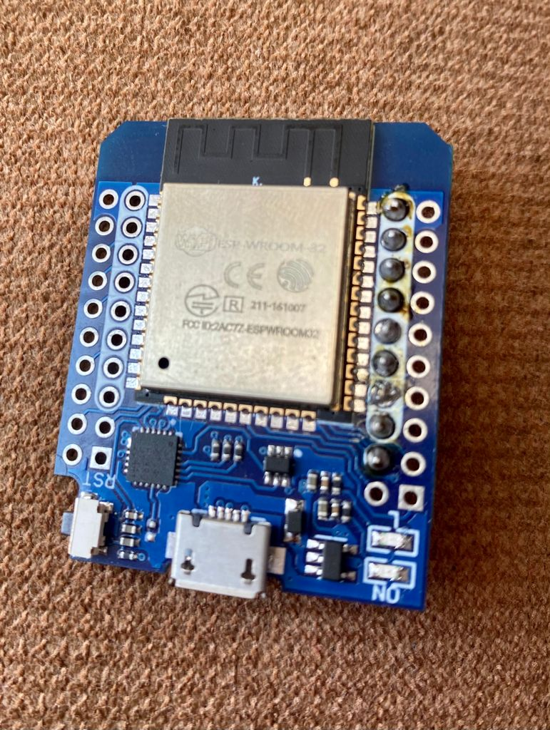 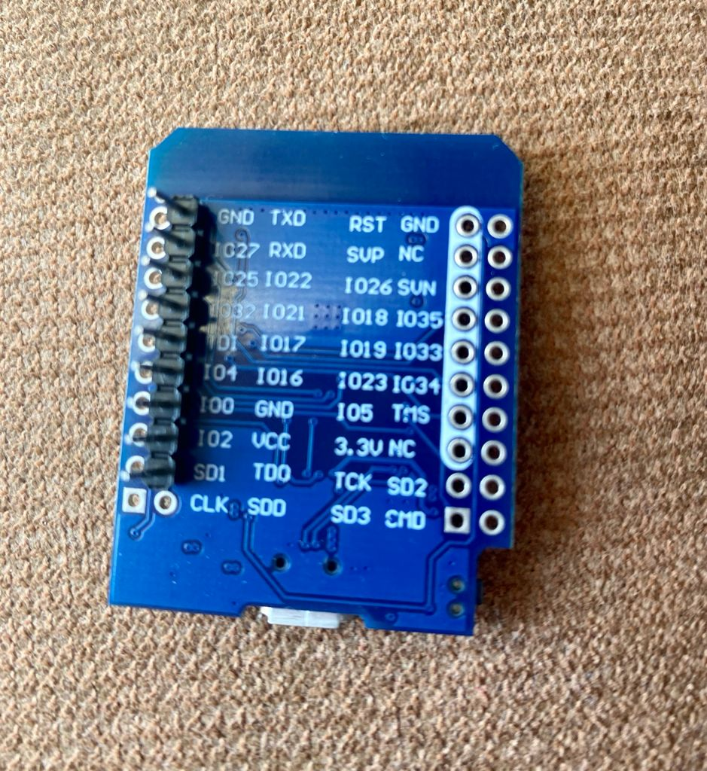

The ESP32 development board is a microcontroller that has intergrated Bluetooth and WiFi. On the image above, it is placed on an adapter with usb connection for powering. I programmed it using Arduino IDE. I had to download and install esp32 library. After opening a new project, I connected my device and selected it on the tools board menu and it was connected to PORT: COM4

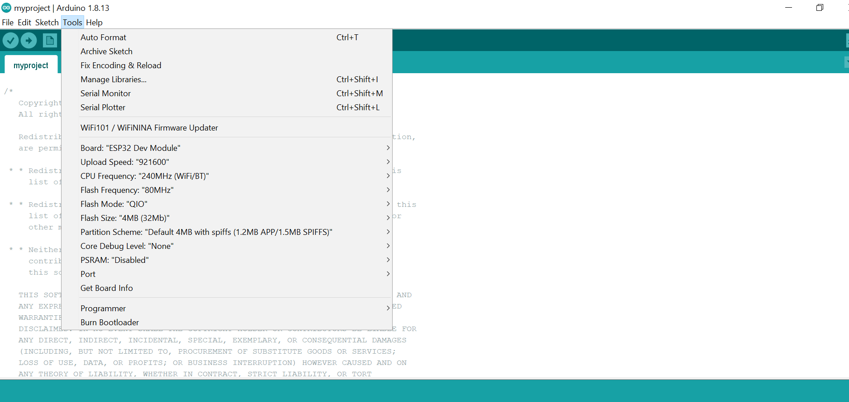

*Esp32 arduino ide*

2.Gps module x 1

The gps will Vcc and ground will be connected to the esp32 Vcc and ground respectively. I had to download and install Tinygps++ library to be able to interact with the gps. The standalone gps receiver on the module will search for sattelites and get its global positioning coordinates. The images is shown below. To send the coordinates, I connected the TX pin of the module to pin 16 on my Esp32.

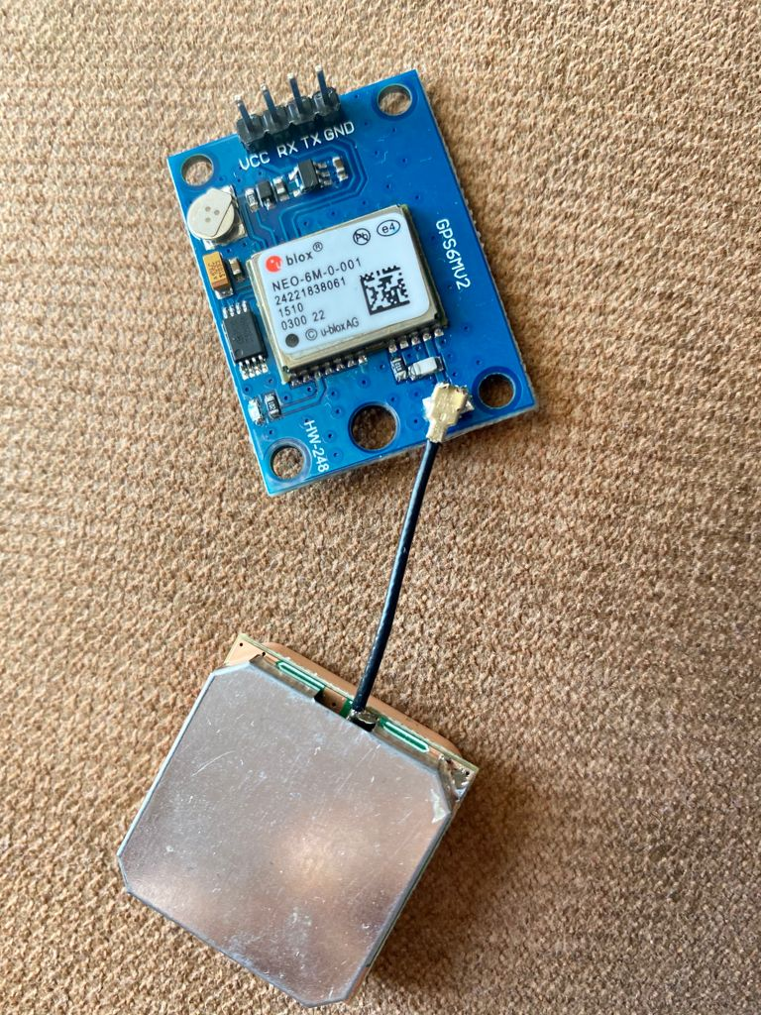

3.Breadboard x 1

4.Connecting wires

The image below shows an ESP32 wifi module connected to a neo6m gps module.

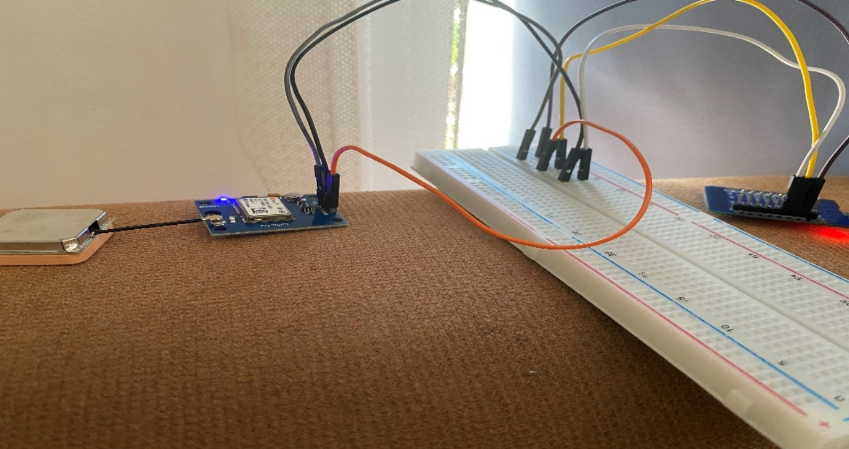

*Figure7 Esp32 and Neo 6M gps module*

**Connection:**

|  |  |
| --- | --- |
| **Gps** | **Esp32** |
| Vcc | Vcc |
| Ground | Ground |
| Rx | 16 (defined as RX) |
| Tx | 17 (defined as TX) |

*Table 1 hardware*

The Esp32 is powered by a laptop using the usb connection. I used espSoftware serial header to connect the gps and the esp32 on the Tx(send) to 16. I also included the:

* **Wifi** library connect to the wifi using the wifi credentials.
* **Wificlient** for communicating with thingspeak
* **Thingspeak** library to send the data to things speak

for communication with thingspeak, I had to create a things speak project and get the writeapikey and the channel number.

When serial communication begins, the antenna searches for the satellites near its area and gets the gps latitude, longitude. A tinygps++ object will receive the coordinates, encode them and pass them to thingspeak. If there is a wifi connection, channel from thingspeak will be accessed and the gps coordinates will be saved online.

**The Arduino IDE Code**

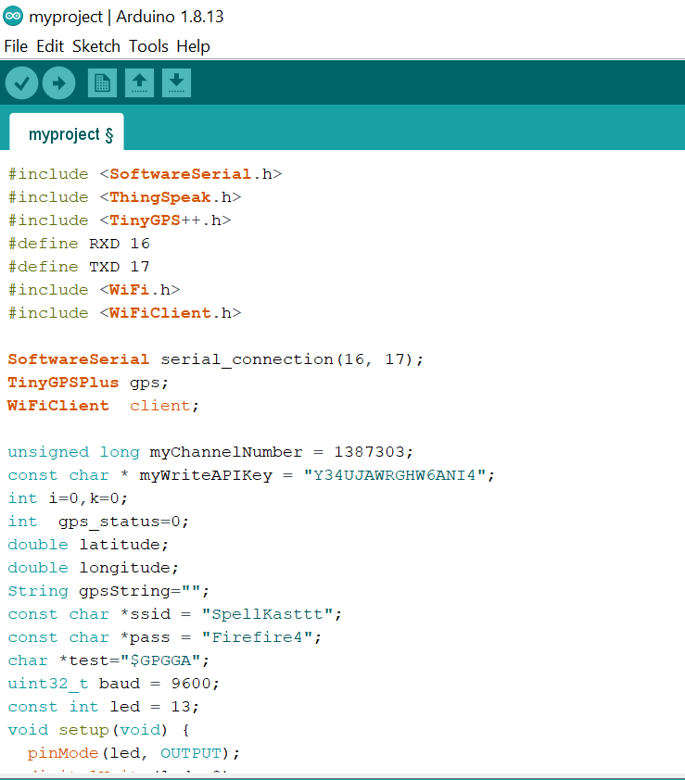

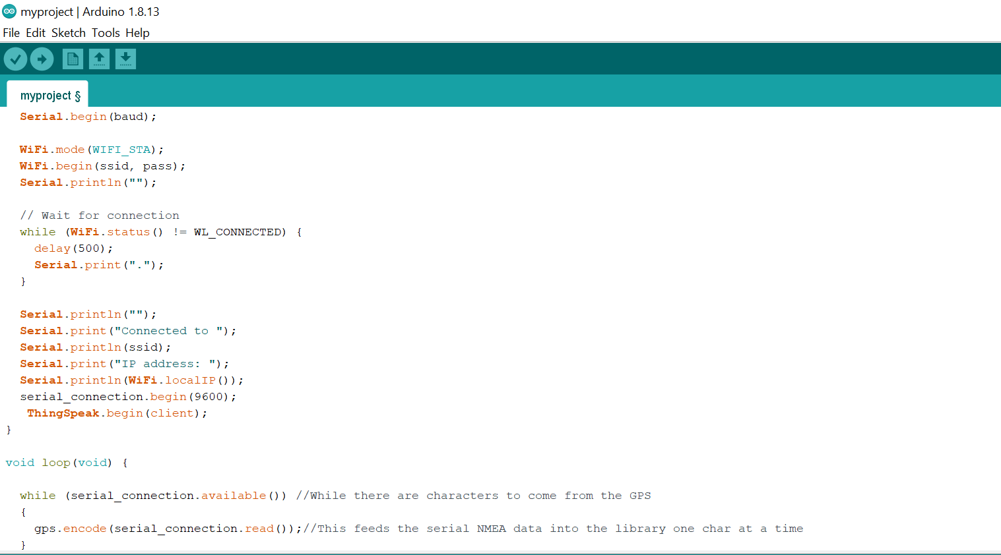

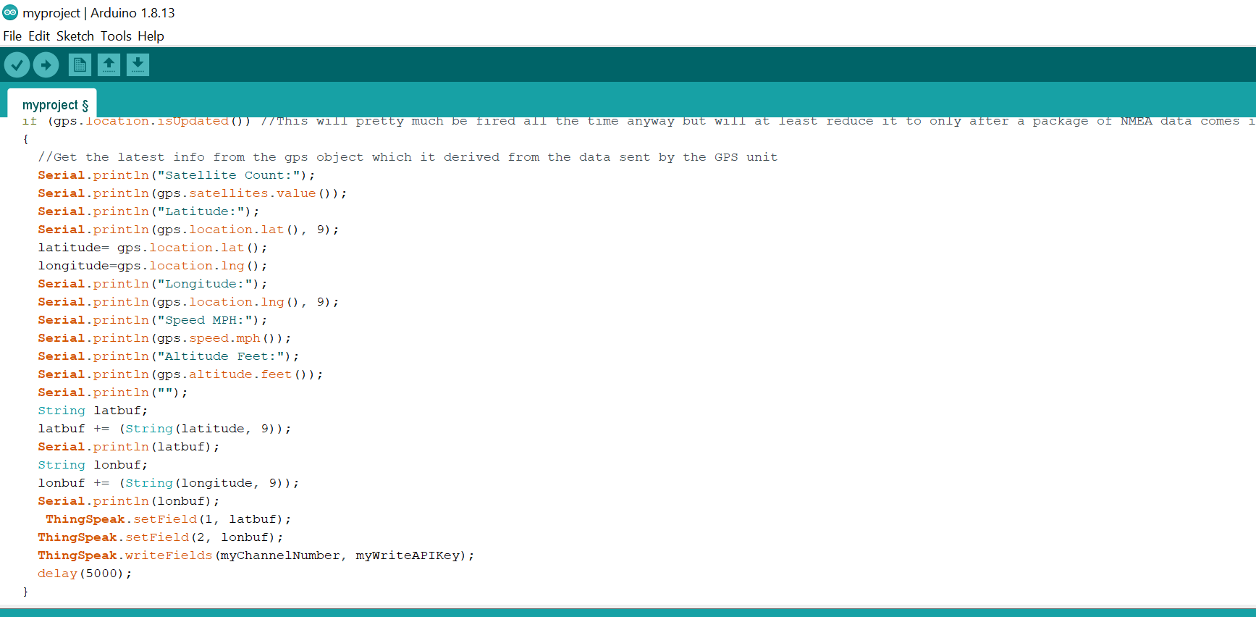

# Methodology

1. **USER**

## Login Module

The users will be able to access the website by entering their credentials on the login module. Only registered personnel will be saved in our database.

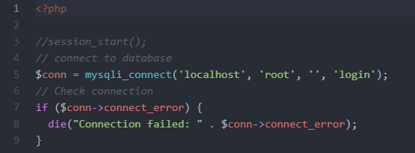

*Figure8 Database connection*

Students and drivers will initially be given the details to log in. If the information entered on the login module does not match our database, access will be denied and an error message will be shown.

If the information matches our database, the user will automatically be directed to our home page. They will be given the option to personalize their passwords after. A login module is a form of security because it ensures that only people with permission will be allowed to access the system.

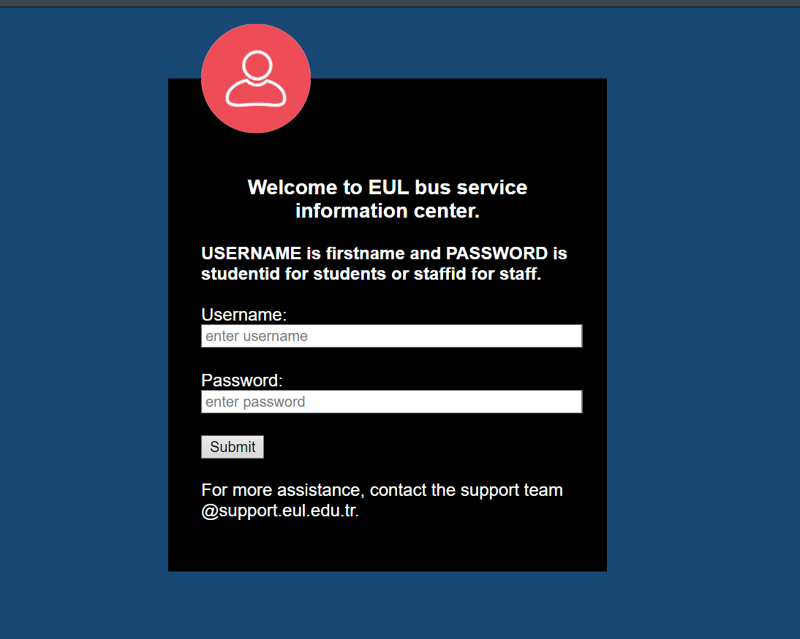

1. **Home page**

After login, user is directed to the home page shown below. The session username is displayed on the top right.

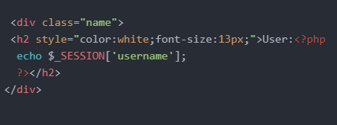

We also have a logout page for when the user is done and they want to exit. The menu has 4 links redirecting to different pages. On the home page, user and see an announcement section, a small about us section and a routes section which all have a redirecting links to different pages. The footer has some contact issue and address of the school. This is the general layout of the whole website achieved by Html, css , bootstrap and javascript.

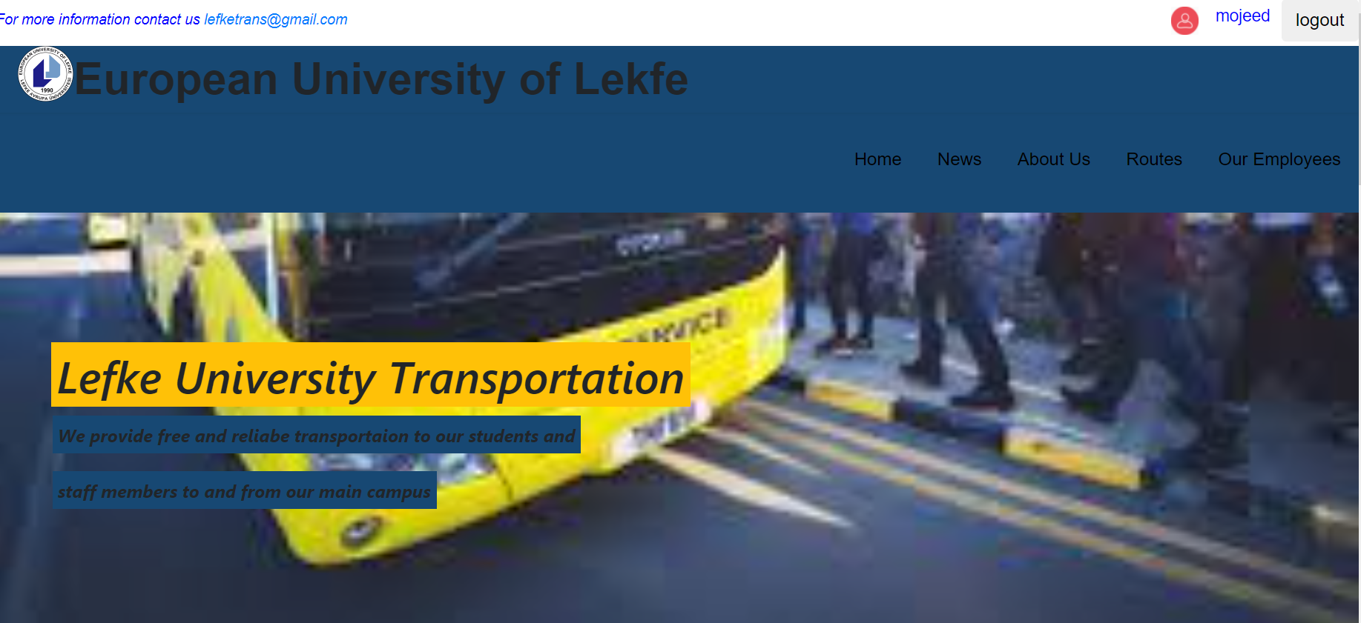

*Figure 24 home page*

## Routes Module

The routes module will be found on our home page after a successful login. It will have a drop menu that has a list of all the different destinations that the school bus will be moving to. If the user picks one of them, for example, Doganci, they will be redirected to a new page that has all the information about the destination.

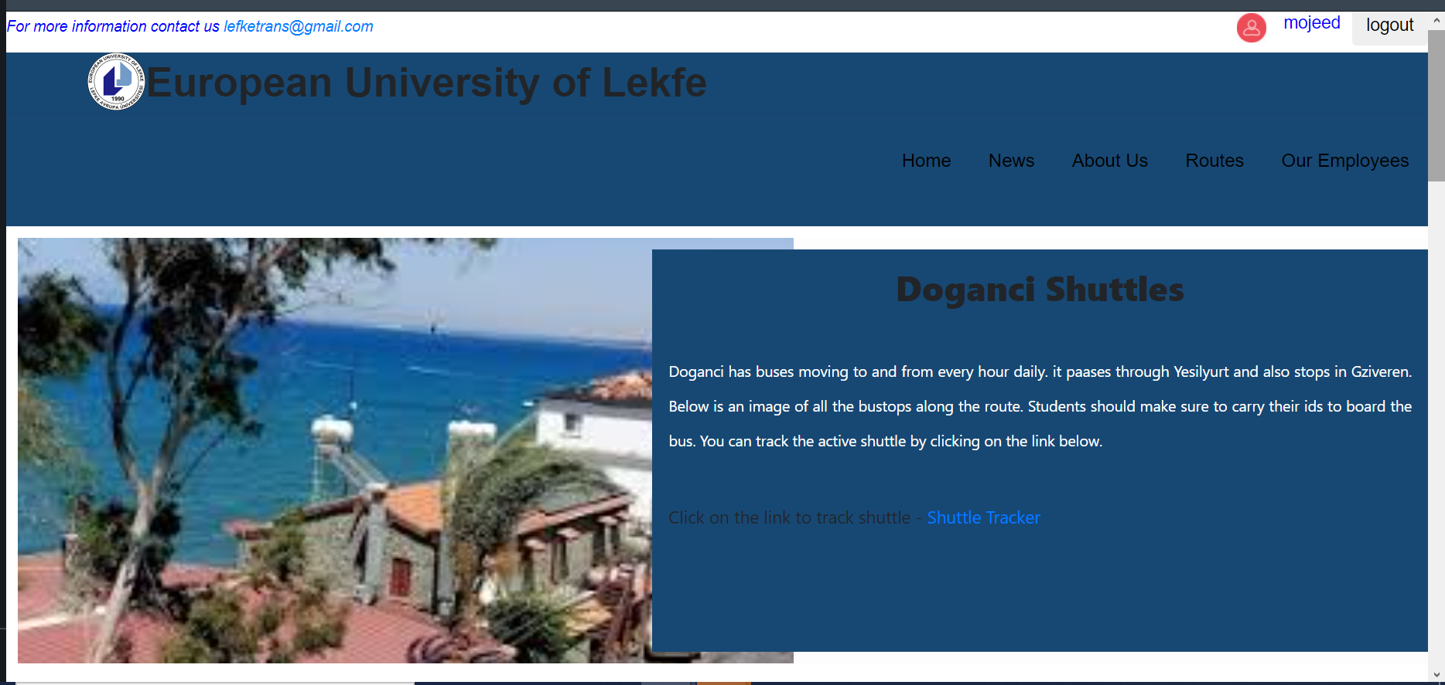

*Figure22 routes page*

There will be two timetables to show the times from the destination to the school campus and vice versa. The page will also show the route taken by the bus to the destination including all the school bus stops along the way. There will also be a section for the announcements that concern only the particular destination chosen. The option to track the school bus will also be included on this page.

***Thingspeak***

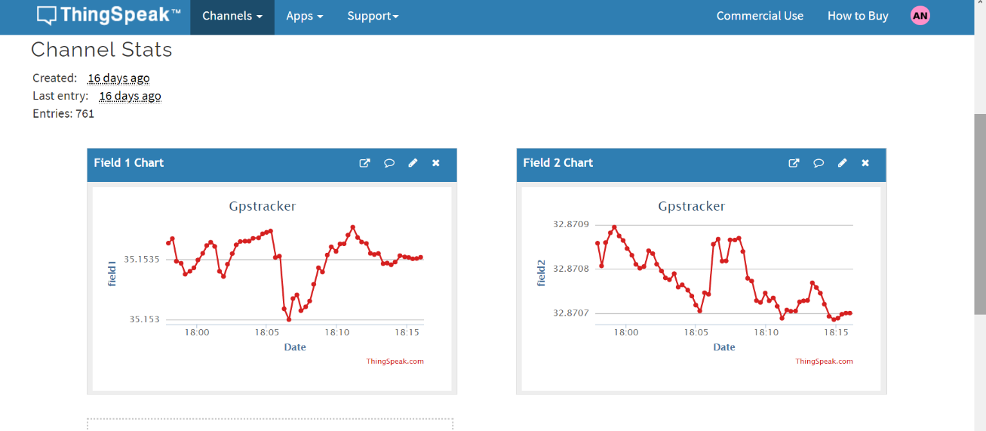

*Data received from esp32 and gps tracker*

The php code below receives latitude coordinates from Thingspeak sent from the esp32 and gps tracker using getJSON function. The results are stored in variable x and y. These variables are then passed to google map position and displayed.

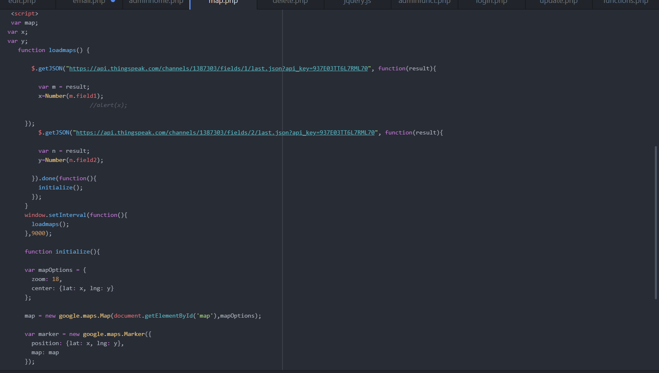

*Figure9 Map php code*

The result from the php code above will be displayed for the user as shown below. The marker will shown the position of the bus at all intervals. User can also see the satellite view of the location.

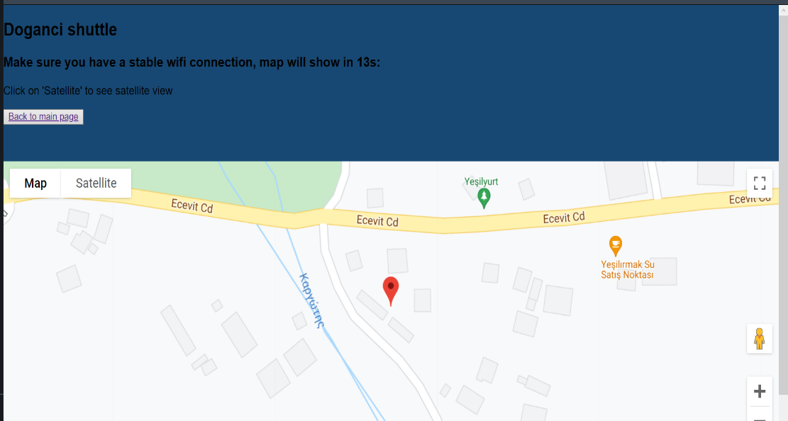

*Figure 10 Map*

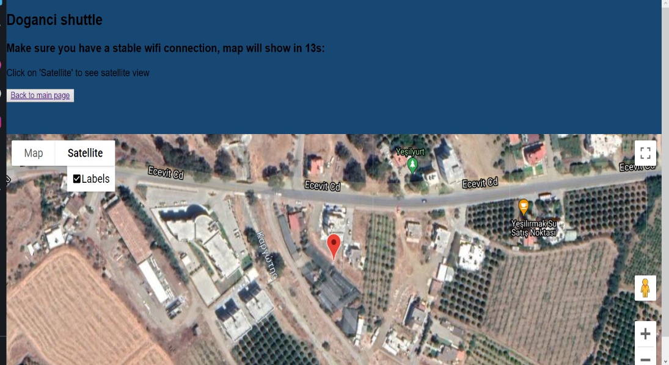

*Figure10 Map*

## d)News Module

The news module will also be on the home page. It will also redirect to a different page. The first section on the page will contain safety measures and regulations to be followed by all students who want to use the school bus. The second section will be for important announcements and daily updates concerning transportation.

For example, if the school bus will not be available, an article will be added to this module to inform readers. This module will basically be responsible for sending out information that the users will need to know about the school bus. It will be maintained and updated on daily basis.

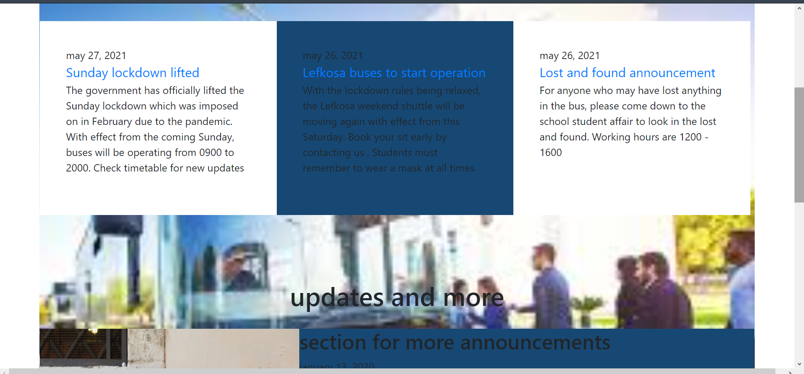

*Figure 23 news*

**e) Driver's Module**

The driver's module will be a page about the employees. There will be a little information about the employees who drive the buses that includes their qualifications and a gallery. The importance of this page will be for the students to know who will be driving them so that they feel safe. There will be a schedule included to show who will be working at a particular time. This will be useful to the drivers as well because they will be able to log in and check their schedules online.

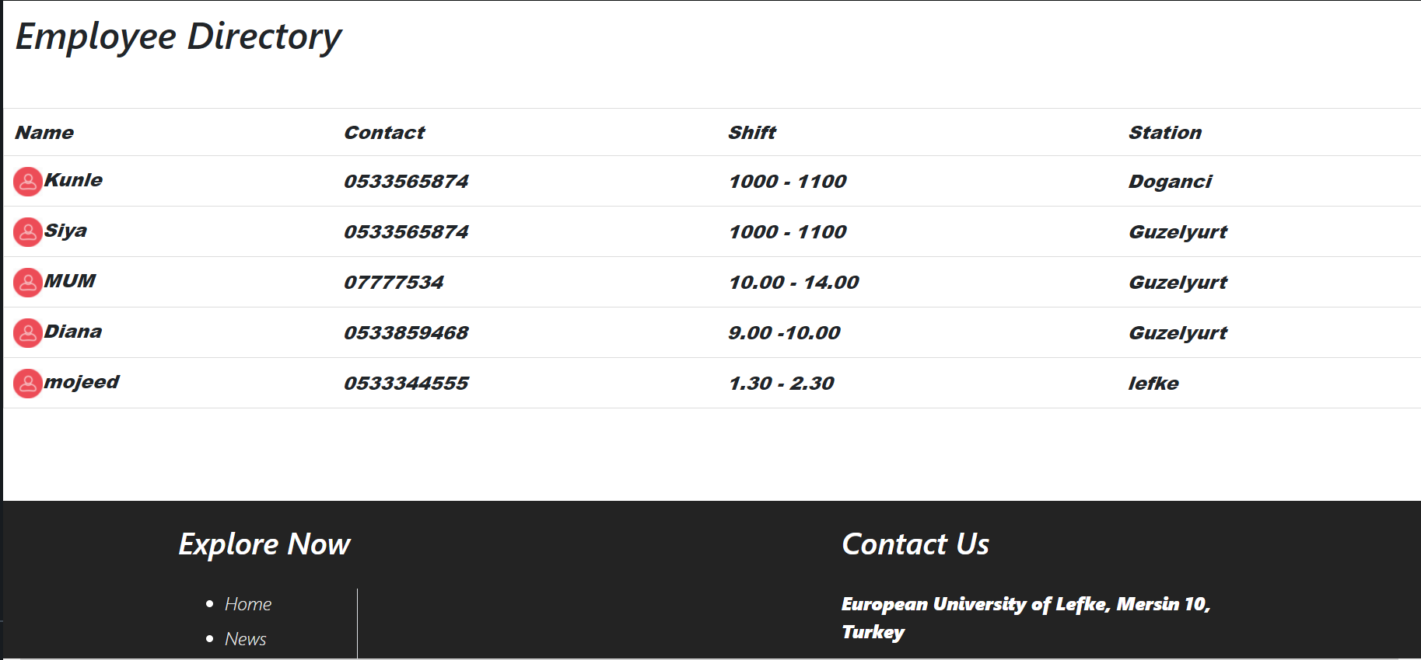

*Figure11 Drivers*

**f) About us Module**

This module will have information about the transportation department on how they started operating, the achievements, the school mission, and any future plans. A gallery will be included on this page to show pictures of the buses, the school bus stops, the parking lot, and any other relevant pictures. The contact information will also be found on the page. Users will be able to contact the administration for any inquires. The head of department contact information will also be included.

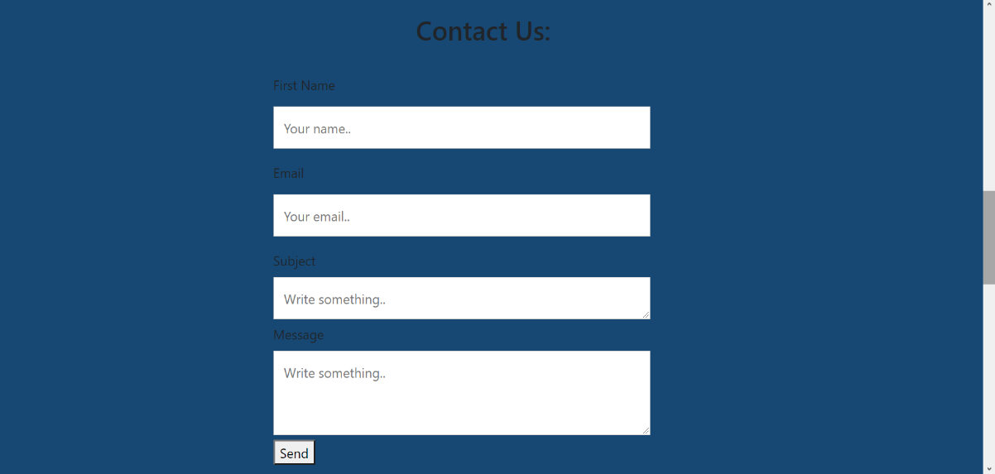

*Figure13 sendemail*

When the users fills the form above, the details are sent to a php through POST method, where a new phpmailer object is created and the email is sent to an already defined addresswith the details entered.

*exPlain phpmailer*

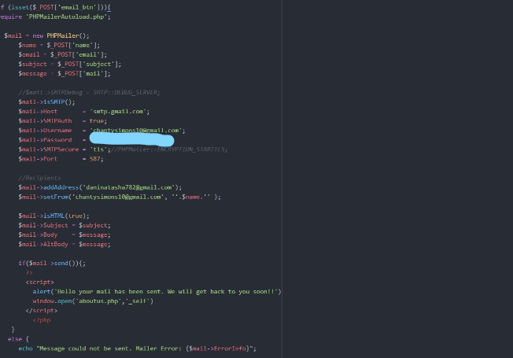

*Figure12 phpmailer code*

**2.Admin Dashboard**

**a) Login Module**

Admin also has to go through the login page. When their details are verified, they are redirected to the admin dashboard. The admin dashboard has a php code to check if the user is an admin and if not they will not have access.

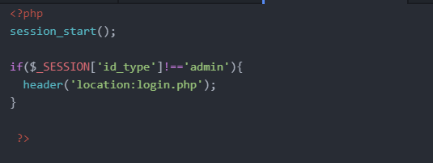

*Figure13 adminchecker*

This is how the admit dashboard will look like. The usernameis displayed on the top left of the page and there is a logout button at the top left. The admin can pick from the list the action the want to do.

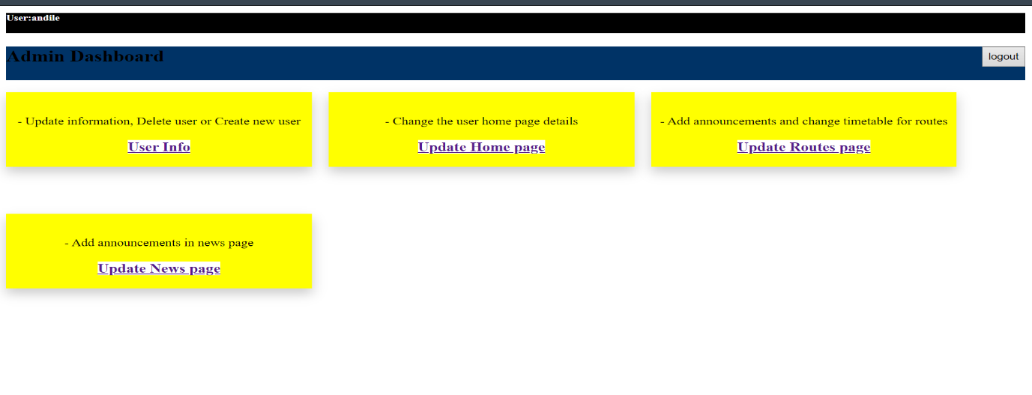

*Admin Dashboard*

**b)Update user and Delete user**

When the admin clicks on View user info, the user info will be displayed from the database in athe table on fig 18. They will now have the option to update the user info by clicking on the edit user button.

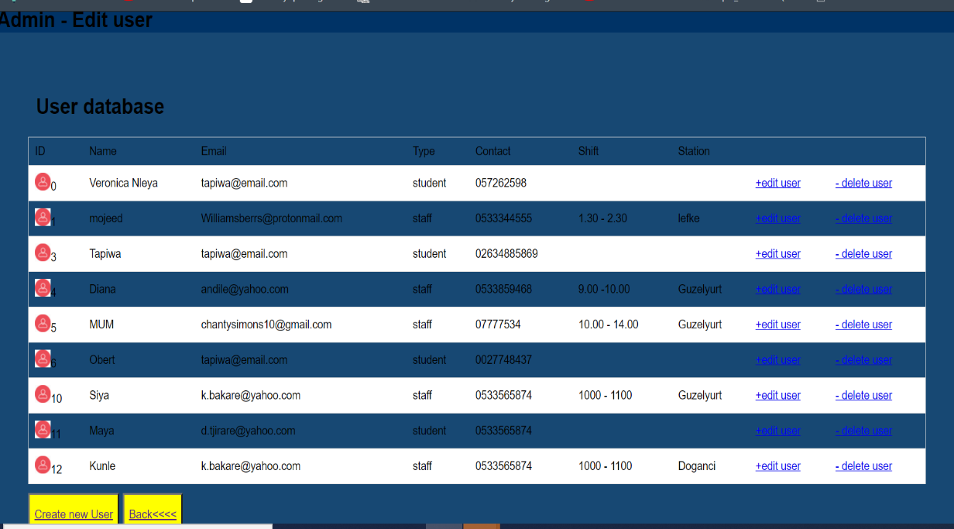

*Figure18 User info*

The form on fig 19 will be shown and the admin will edit the information they need to edit. The query will be sent to the database and if the information is valid, there will be an update and an alert shown on fig 19 will be displayed. This is the general layout for the admin and managing database information.

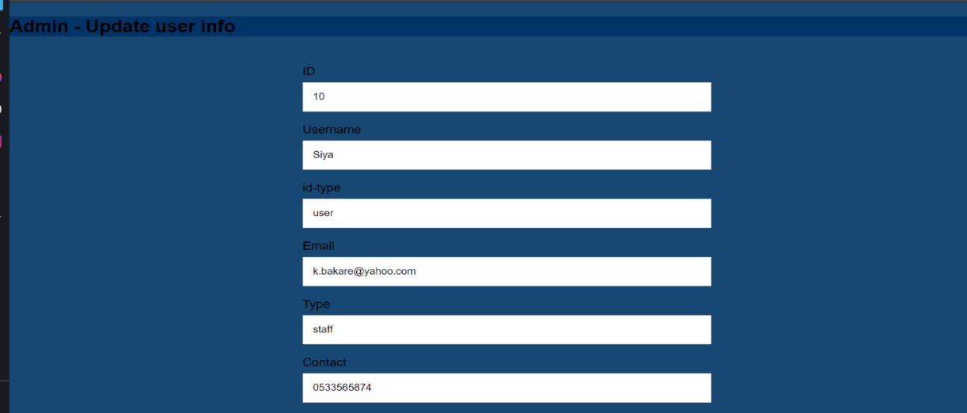

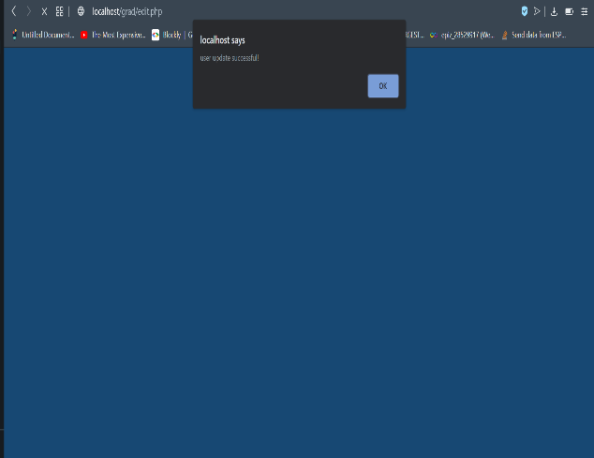

*Figure 19 update user form*

**c)Create User**

When the admin clicks on the create user button shown on fig 18, a form will be shown for the admin to enter new user information into the database. If the information entered is valid, an alert to notify the admin on the success will be displayed and a new record will be entered into the database.

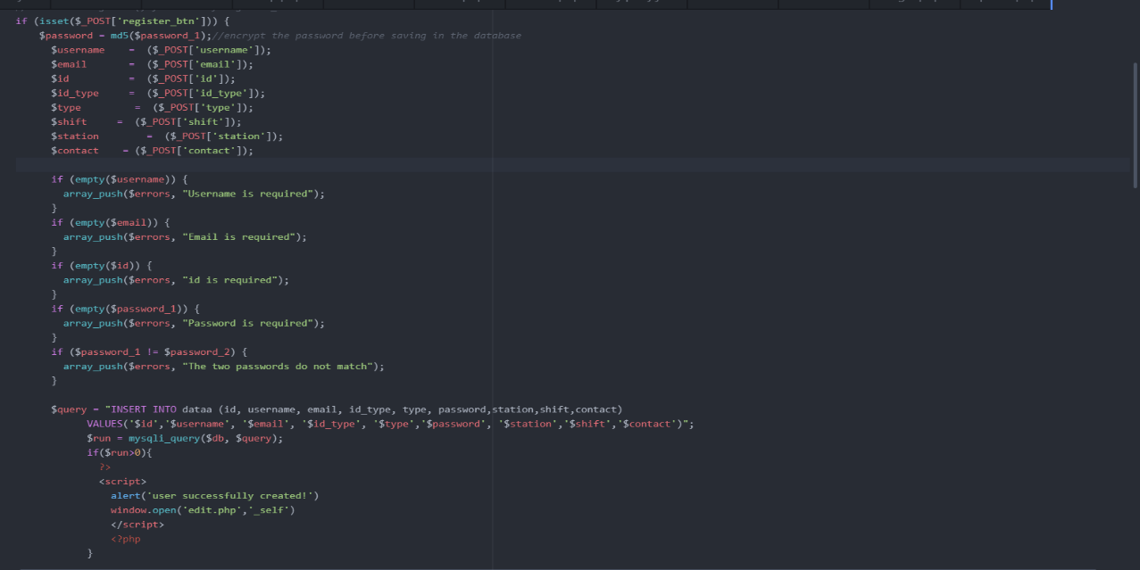

*Figure 25 create user php*

1. **Edit Timetable**

When the admin clicks on update routes page on the dashboard, they will be redirected to a page where they can edit the announcement and the routes timetables for routes. Fig 20 above showns an example of the Doganci route timetable.

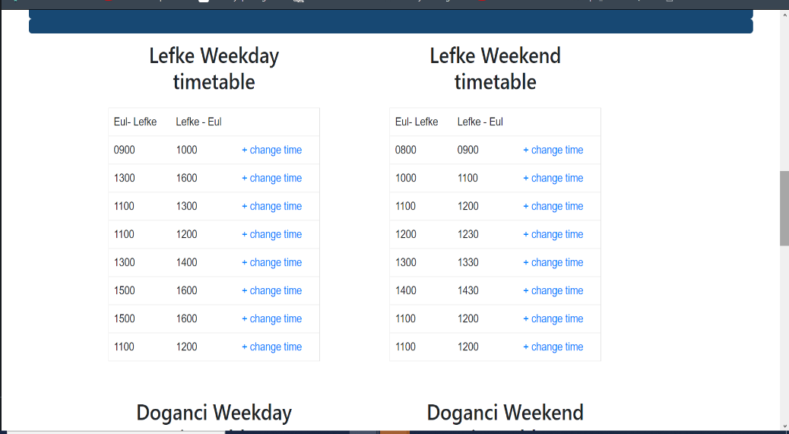

*Figure 19 routestimetable*

When admin clicks on change, the form on the left on Fig 21 will be displayed and new values for the timetable will be entered. On success, the database is altered and an alert will be displayed to notify the admin.

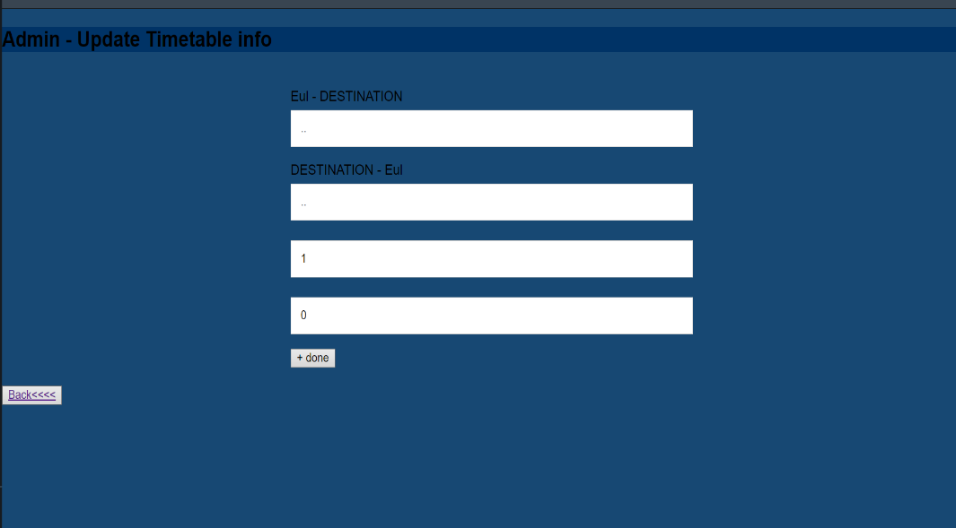 *Figure 20 edit timetable*

1. **Edit news**

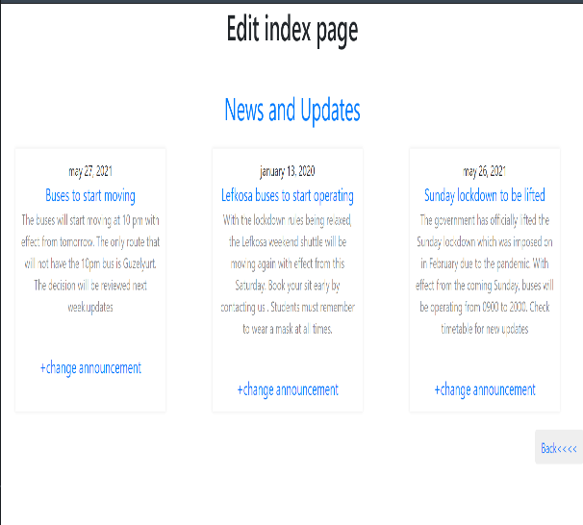

*Figure 21 Edit news*

When the Admin edits the news section, when the click on change announcement, a form is displayed to enter the new announcement. And the details are sent to the php code above. The particular message is changed in the database and an alert notifies the admin

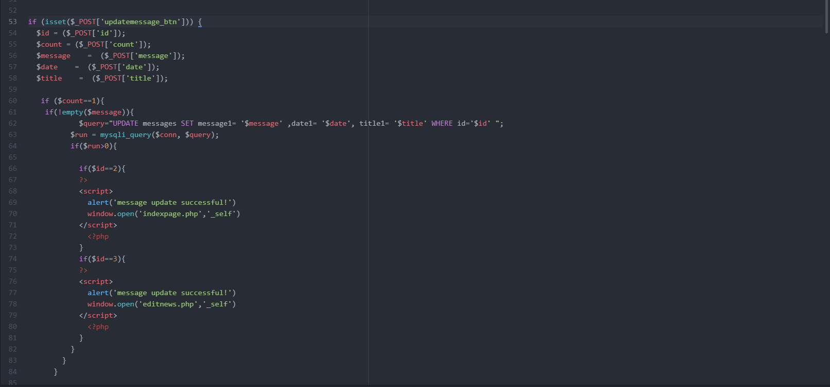

*Figure 22 phpcode*

1. **Conclusion**

## 6.1 Benefits

**a) Benefits to users:**

* Easy access to information about the school bus
* Students will be able to catch the bus on time when using the tracker
* Admin can monitor the bus movement for security purposes
* Students have direct communication with the admin.
* The drivers will be able to see their schedule and any important notifications.

**b)** **Benefits to me:**

* Building the website from scratch will help me test my skills in real-life situations
* I learnt how to connect hardware (Arduino) to my software practically
* I was able to identify my weaknesses and improve
* The research has made me learn a lot of new information
  1. **Ethics**
* Most of the work on our web pages will be authentic and references will be included for any copied information.
* The website will not use any material withheld by copyrights.
* The website will have a secure login for protection against bugs and viruses.
* Users' information will not be accessible to any other party.
* No spam or chain messages will be allowed [3].

## 6.3 Future Works

Some institutions already have websites similar to mine. I want to make sure that this project will actually be practical so it can be used by the school after my graduation. I will like to add more functionalities like a button to book a sit on the bus before the trip and to show when a bus is full. This will be useful because it can notify the admin to add a bus so that students are not left out. I will continue to research further to improve the system that I will build and add other features as well.

**Why did I choose this project?**

As a student, not having adequate information about the school bus has been an issue. I was having a conversation with my friends and the idea came to me. The main objective is to improve the life of students. The website will have the school timetables and if there are any changes, the news module will make announcements. Since the bus movement is not constant due to traffic and other factors, the tracking features will help the student to know exactly where the bus and catch it on time. This feature will also be useful to the administrators. They will be able to monitor the movement of the buses to ensure the security of the students.

1. **References**
2. European University of Lefke – Life at EUL – Transportation, [www.eul.edu.tr/laude-yasam/hizmetler/ulasim/](http://www.eul.edu.tr/laude-yasam/hizmetler/ulasim/)
3. 2. Colombia Transportation,

<https://transportation.columbia.edu>

3. Harvard Transportation and Parking,

4. Ethical and Legal Issues in Web Development, 2013 Certification Partners, LLC

5.

[https://www.w3schools.com]( https://www.w3schools.com)

6. <https://www.wikipedia.org/>